Horizon Fuel Cell Technologies Pte. Ltd.
6 Penhuru Close #03-01
Singapore 608614
Contact: taras@horizonfuel.com

FOR IMMEDIATE RELEASE

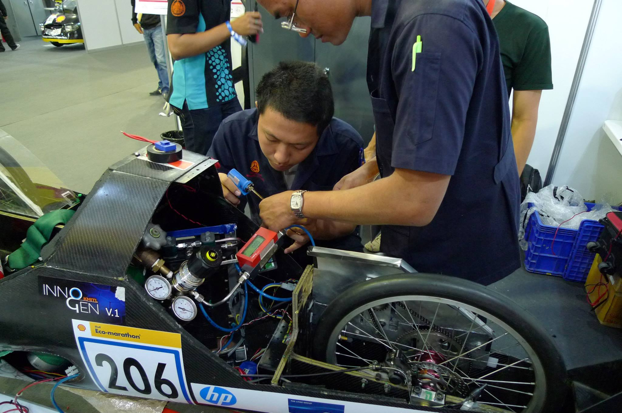

Horizon’s fuel cell powers up Malaysian team to 1st place at Shell Ecomarathon

Singapore, February 13, 2013 - UITM Malaysia swept to victory at this year’s Shell Eco Marathon Asia which took place in the Philippines, last week - achieving success in both the Urban Concept and Prototype categories. Horizon’s XP series fuel cell stacks provided the power and helped propel the team to a fantastic double triumph. Not only that, but the second place participant also used Horizon hybrid technology – making 2014 the fourth consecutive podium year for Horizon’s high performance XP fuel cells.

This year over 100 teams from the top universities and Engineering institutes all over Asia competed to design the most energy efficient vehicles capable of travelling the longest distances. Each vehicle is given the same amount of energy and then put through its paces in a series of endurance and safety tests conducted by Shell engineers.

At 59% peak efficiency, the Horizon H-1000XP fuel cell used for the best vehicles on the field is a product of years of continuous collaboration with university teams and ex-champions of the Eco-marathon competition. This year Horizon is introducing a new 500W fuel cell option, the H-500XP – lowering entry costs and improving performance for participants in the prototype category.

Horizon XP stacks are designed for quick and easy integration, essentially a “plug and play” setup that allows engineers to concentrate on other aspects of design, the XP series also comes with software and communication ports to allow in-depth analysis and data tracking.

"Congratulations to the UITM Malaysia team on their well-deserved success." Horizon founder and Chief Marketing Officer, Taras Wankewycz said earlier today, "Horizon is proud to be involved in the Shell Eco-marathon and to collaborate with teams like UITM. Together we’re proving that fuel cells are the future of transport— the most efficient, the most reliable energy storage solution for tomorrow’s zero carbon emission vehicles."

About Horizon Fuel Cell Technologies (http://www.horizonfuelcell.com/)
Horizon Fuel Cell Technologies Pte Ltd was founded in Singapore in 2003 and currently operates 5 international subsidiaries, enabling several markets with fuel cell products and on-demand hydrogen solutions. Horizon has emerged as one of the world's largest volume producers of commercial fuel cell products, serving retail, industrial and OEM customers in over 65 countries. www.horizonfuelcell.com

